Prague Sounds presents The Concert For Europe: the Czech Philharmonic perform on the river Vltava to mark the Czech Presidency of the Council of the EU

Prague, 7th April 2022 – The latest in a line of exceptional outdoor concerts put on by the Prague Sounds festival will take place on September 2nd, 2022. The venue will once again be the festival's unique purpose-built floating stage on the river Vltava in the heart of the city. In co-operation with the Czech government and the Czech Philharmonic, this year's concert marks the Czech presidency of the EU council and will be called The Concert for Europe. Concertgoers will be able to enjoy the event from the floating auditorium - as well as the river's nearby bridges, embankment, and islands - as Semyon Bychokov conducts the Czech Philharmonic in a programme featuring Beethoven's Ode to Joy, Smetana's Vltava, Dvořák's Carnival Overture, and one of the most astonishing sacred works in all music: Janáček's monumental Glagolitic Mass.

'In 2020, during the coronavirus pandemic, we put on our first concert on the Vltava,' says festival director Marek Vrabec. 'It was called Hope for Prague, as the British violinist Daniel Hope sent a message to the world that music can bring us together even in the darkest of times. A year later, in the same spot, we celebrated 25 years of the festival with a week-long open-air series of concerts headlined by the phenomenal cellist Yo-Yo Ma with his stunning interpretation of Bach's solo suites. We're proud to have been chosen to put on this concert to mark the year of the Czech presidency, which will be a celebration of our common European home and values – something that is particularly pertinent in this time of war.'

As well as the Czech Philharmonic and Semyon Bychkov, the concert will feature the Prague Philharmonic Choir, led by Lukáš Vasilek, and soloists Evelina Dobračeva (soprano), Lucie Hilscherová (mezzosoprano), Aleš Briscein (tenor), Jan Martiník (bass), and organist Daniela Valtová Kosinová. Further information about the programme is available at koncertproevropu.cz, where tickets can also be

purchased. The concert will be broadcast live by Czech Television, and European cultural channel TV arte will broadcast a recording of it.

'The Czech Philharmonic is thrilled to be part of this special concert, and to have the opportunity to perform in such a breathtaking setting, with historic Prague providing a beautiful backdrop,' says David Mareček, the director of the Czech Philharmonic.

The concert, which will be seen around the world, will more than just a musical celebration, according to Prague mayor Zdeněk Hřib: 'The Presidency of the EU council gives us a chance to show the world the best of our city – so I'm delighted that the concert is happening right in the beautiful heart of the city on the river Vltava.'

Programme:
Ludwig van Beethoven: Ode to Joy
Antonín Dvořák: Carnival Overture
Bedřich Smetana: Vltava, a symphonic poem
Leoš Janáček: Glagolitic Mass

Participants:

The Czech Philharmonic

Prague Phiharmonic Choir

Evelina Dobračeva – soprano

Lucie Hilscherová – alto

Aleš Briscein – tenor

Jan Martiník – bass

Daniela Valtová Kosinová – organ

Conductor: Semyon Bychkov
The Prague Sounds Floating Stage
The Prague Sounds floating stage provides audiences with the opportunity, once a year, to experience an exceptional concert right on the Vltava river, with historic Prague forming a breathtaking backdrop. The stage is situated in the heart of the city, between the National Theatre and Slovansky Island, on the so-called 'Vltava Mirror' downriver from the Old Town weir.
For the Czech Philharmonic's first-ever concert on the river, the floating stage will be expanded to accommodate 170 participants. The audience capacity will also be increased to enable 1200 people to enjoy the concert from the auditorium, in addition to those watching from the nearby bridges, islands, and embankments, or indeed from pedalos and row-boats on the river.

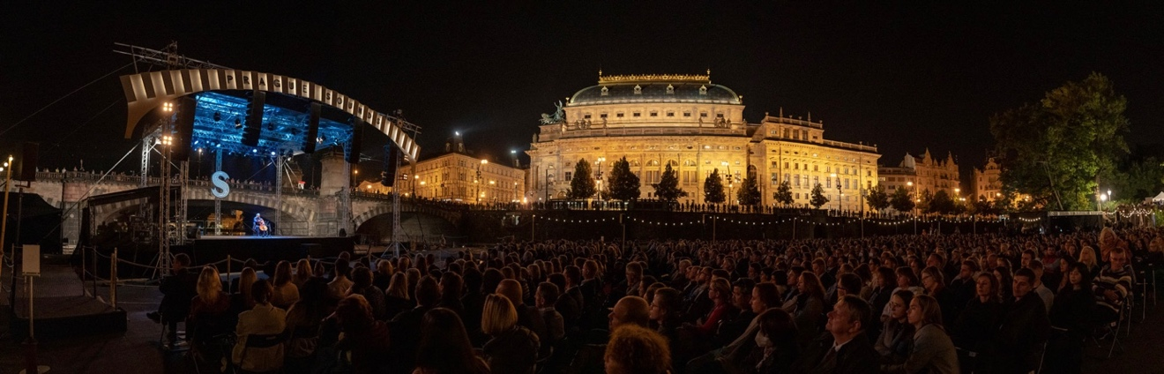

PRESS KIT:
https://www.dropbox.com/sh/op51in02be7zdln/AACOjaUvRV__L66b71x_jBfXa?dl=0

More detailed information at: www.koncertproevropu.cz.

Further information:
Radek Babička
mediální servis
M: +420 723 036 041
E: babicka@praguesounds.cz

The Concert for Europe is organised by:
Prague Sounds s.r.o. In co-production with the Czech Philharmonic
Producer: Marek Vrabec

The Concert for Europe takes place with the support of the Government of the Czech Repubulic, the City of Prague, and the Czech Ministry of Culture.



