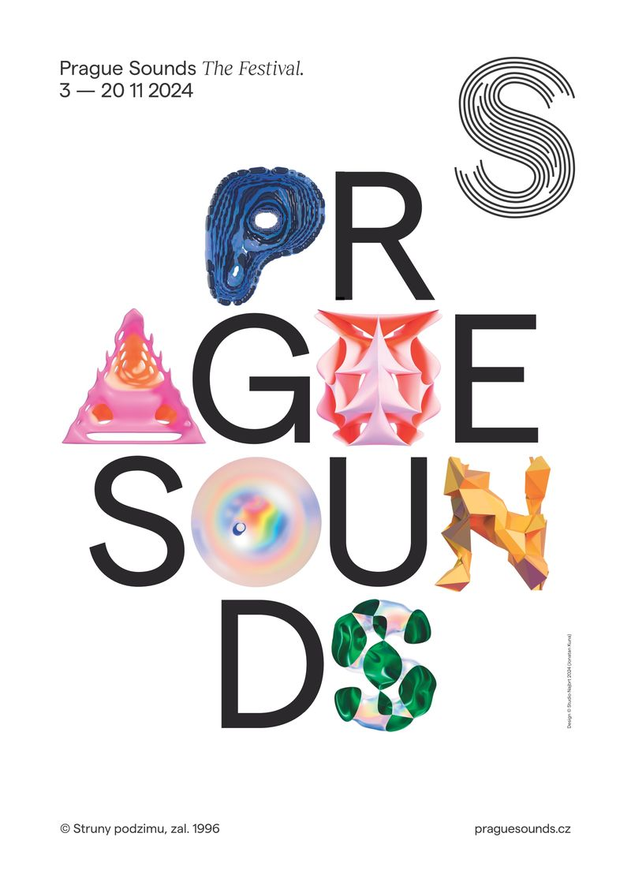

Branford Marsalis, Nubya Garcia, Tigran Hamasyan, Oneohtrix Point Never, and more at Prague Sounds

David Koller a Richard Müller pay tribute to Karel Kryl; Katarzia curates an evening featuring young woman artists

Prague, June 3rd,2024 – Big names from the world of jazz, contemporary vocal music, electronica, alternative hip-hop, and world music, Czech premieres and unique one-off festival projects: the 28th edition of Prague Sounds offers up all this and more, from November 3rd to 20th at a range of venues across Prague. Branford Marsalis, one of the greatest saxophonists of the last forty years and a three-time Grammy winner, comes to the festival with his virtuoso quartet. Oneohtrix Point Never, an icon of the experimental electronica scene, brings his audio-visual wizardry to the festival. We can also look forward to concerts by Nubya Garcia, one of the most distinctive artists on the London new jazz scene, and a solo recital by Armenian pianist Tigran Hamasyan, whose unique mix of Armenian folk and jazz modes has made him a worldwide star. The best in American alternative rap is represented by Moor Mother, billy woods, and McKinley Dixon, and the wildly inventive South African cellist Abel Selaocoe comes to Prague with acclaimed British contemporary music ensemble Manchester Collective. Groundbreaking American vocal ensemble Roomful of Teeth will perform the Czech premiere of the Pulitzer Prize-winning composition Partita for 8 Voices, written by composer Caroline Shaw, who performed at Prague Sounds in 2021.
The festival this year also presents two new and orginal domestic projects. David Koller and Richard Muller come together at Rudolfinum to pay tribute to the legendary songwriter Karel Kryl. And there's the first in a new series of specially curated concerts showcasing exceptional young Czech and Slovak artists - the curator this year is Katarzia, who has chosen the Slovak duo Lash & Grey and Czech singer-songwriters Nika and Johanela for this special event. Tickets for all festival concerts are on sale now at www.praguesounds.cz.

'I'm glad we can once again present our audience with a range of international artists making their Czech debuts,' says festival director Marek Vrabec, 'as well as new one-off festival projects. Following on from tributes to Jiří Suchy and Jiří Stivín in previous years, we're preparing a special celebration of songwriter Karel Kryl, in a double anniversary year for this unique artist. I got in touch with David Koller and Richard Müller and we're planning a very special evening at Rudolfinum. Both artists were so keen to do this project that it came together more quickly than any other show in the history of the festival.'

This year's Prague Sounds starts on November 3rd at Lucerna, with the legendary Branford Marsalis Quartet. 'Although he's most at home in jazz, Branford has left his mark in many other genres, from pop to funk and hip-hop, and even classical music,' says Vrabec. 'He's recorded and performed with Sting and the Grateful Dead, and he comes to Prague at the peak of his powers.' Marsalis will be joined by pianist Joey Calderazzo, bassist Eric Revis, and drummer Justin Faulkner.

On November 4th at La Fabrika, there's a unique double bill featuring two of the most compelling voices in alternative rap and poetry: Moor Mother and billy woods. Moor Mother, a lyrical force of nature from Philadelphia, will perform at Prague Sounds in a duo with electronica and drums. Her work brings together elements of rap and poetry with electronica, free jazz, punk, and sound collage. 'Moor Mother is an artist of rare conviction,' says festival programmer Guy Borg. 'Whether tackling racial tension, domestic violence, or slavery, hers is always a defiantly compassionate voice.' The second set of the night will be performed by billy woods, one of the most respected American underground MCs, who surrounds himself with an aura of mystery. 'woods's music features erudite lyrics and a beguiling flow, along with hypnotic beats and instrumenal samples providing echoes of jazz and blues,' says Borg.

The festival returns to Lucerna on 5th November for cellist Abel Selaocoe's concert with British contemporary music ensemble Manchester Collective, which promises to be a wild and genre-defying ride. 'The Sirocco project includes group improvisations, interpretations of folk songs from Europe and Africa, and of compsitions by Haydn and Stravinsky. The result is a thrilling melting-pot of music that encompasses a breadth of cultural tradition from around the world,' says Marek Vrabec.

Brooklyn-based Daniel Lopatin, otherwise known as Oneohtrix Point Never, has been called a visionary of electronic music. On November 7th at Archa+, Lopatin will take the festival audience on an audio-visual adventure, with bespoke video and light design complementing his extraordinary music. Oneohtrix Point Never has produced for FKA Twigs, David Byrne, and Anohni, as well as composing music for films such as Uncut Gems. 'But it's his solo work that really marks him out,' says Guy Borg. 'It takes in an unbelievable range of influences,, from minimalism to noise to collage, juxtaposing the old and the new – samples, synths, acoustic instruments, snippets of dialogue from 90s TV, excursions into alt-pop. It's a unique amalgam.' Oneohtrix Point Never will be travelling to Prague with a team of audio-visual technicians specially for this show.

The festival this year returns to Kasarna Karlin (November 8th) for the Czech premiere of one of the most notable artists on the contemporary American hip-hop scene: McKinley Dixon. 'Dixon combines sophisticated lyrics – at once personal and literary – with infectious beats and a jazz-funk feel,' says Borg. His most recent album Beloved! Paradise? Jazz! is named after three works by the writer Toni Morrison, whom Dixon calls 'the greatest rapper of all time.'

This year marks 80 years since the birth (and 30 since the death) of the Czech songwriter Karel Kryl, and Prague Sounds pays tribute to Kryl with a one-off concert at Rudlfinum on November 12th, featuring David Koller and Richard Müller. 'It's often the case with Kryl that covers of his songs don't hit the spot because he was such an original,' says Marek Vrabec. 'But I think in David Koller and Richard Müller we've found the artists who are up to the challenge. The songs will be performed acoustically and in small ensemble set-ups.'

Prague Sounds also brings a new concept to the table at this year's festival: a curated evening of music and design celebrating the most exciting young artists on the Czech and Slovak scenes. The inaugural curator is the Slovak singer Katarzia, who has chosen to showcase compelling young female voices at La Fabrika on November 13th: Bratislava duo Lash & Grey, and singer-songwriters Nika a Johanela.

Brad Wells, the artistic director of groundbreaking American vocal ensemble Roomful of Teeth, has long been convinced that 'the human voice is capable of so much more' - and the Prague Sounds audience can find out what he means as the group makes its Czech debut at X10 Theatre on November 15th. The performance will include the Czech premiere of the Pulitzer Prize-winning composition Partita for 8 Voices by Caroline Shaw, the brilliant young composer who performed at Prague Sounds in 2021. 'Roomful of Teeth have changed perceptions of what vocal music can be,' says Guy Borg. 'They use traditional vocal techniques alongside innovatory ones – from throat singing and yodelling to whispers and moans and various manifestations of human speech.' Also on the programme are the pieces Psychedelics, by New York composer William Brittell, and On Stochastic Wave Behaviour by Leilehua Lanzilotti, a piece which was itself a finalist for the Puliter Prize in 2022.

'Jazz started out as dance music, and I'm just returning it to its roots,' says uncompromising London saxophonist Nubya Garcia, who performs at Prague Sounds on November 16th at Lucerna Music Bar. 'Her role models were jazz giants like Sonny Rollins and John Coltrane,' says Marek Vrabec, 'but she works with ideas from dubstep, reggae, grime, hip-hop, and calypso – it's a heady and energising brew.'

This year's Prague Sounds closes on 20th November at Rudolfinum, with a solo recital by Armenian pianist Tigran Hamasyan. 'Since he started out, he's been incorprating motifs from Armenian folk music into jazz in fascinating ways,' says Vrabec. Hamasyan has recorded 10 studio albums of largely his own compositions, and his star has grown brighter with each.

For further information on all concerts, and to buy tickets, go to praguesounds.cz.
-------------------------------------------
Videos:
- Abel Selaocoe with Manchester Collective & Chesaba: Sirocco: Ka Bohaleng: https://www.youtube.com/watch?v=mJZ4zd7Acq0
- billy woods & Kenny Segal - Soft Landing: https://www.youtube.com/watch?v=KyYQcms0Shg
- Branford Marsalis Quartet - Snake Hip Waltz (Live): https://www.youtube.com/watch?v=NRPR3GJBjSQ
- Johni - Dreaming about you: https://www.youtube.com/watch?v=Ua69IwN0tDQ
- Lash & Grey - Europavox Festival: https://www.youtube.com/watch?v=YZWfZV7u1ek
- NIKA | Jazzfruit 2023: https://www.youtube.com/watch?v=-Y4uw4xj9cI
- Karel Kryl - Nikagda nězabuděm - Tak vás tu máme: https://www.youtube.com/watch?v=AARr_cfkEGE
- Karel Kryl / Pasážová revolta - Koller, Muller, Olejárová, Nikitin: https://www.youtube.com/watch?v=D7KnrvAmKy8
- McKinley Dixon - Run, Run, Run: https://www.youtube.com/watch?v=xvk6h2Riyww
- Moor Mother - "WOODY SHAW" (feat. Melanie Charles): https://www.youtube.com/watch?v=-TxK3LjJQnA
- Nubya Garcia - Pace (Mercury Prize 2021): https://www.youtube.com/watch?v=Euhq3t7WRDM
- Oneohtrix Point Never - Zones Without People - Live at Coachella 2024: https://www.youtube.com/watch?v=tsbrAorxNeQ
- Roomful of Teeth: Caroline Shaw’s Partita for 8 Voices (Excerpt): https://www.youtube.com/watch?v=oEhYY1mgyEI
- Tigran Hamasyan - @arteconcert's Piano Day: https://www.youtube.com/watch?v=JN_DHZ_98iw

Prague Sounds 2024 - program:

3rd November, Lucerna, 8pm
Branford Marsalis Quartet

4th November, La Fabrika, 8pm
Moor Mother, billy woods

5th November, Lucerna, 8pm
Abel Selaocoe & Manchester Collective

7th November, Archa+, 8pm
Oneohtrix Point Never

8th November, Kasárna Karlín, 8pm
McKinley Dixon

12th November, Rudolfinum, 8pm
Müller/Koller: Kryl

13th November, La Fabrika, 7.30pm
Katarzia's Choice: Lash & Grey, Nika, Johanela

15th November, X10 Theatre, 8pm
Roomful of Teeth

16th November, Lucerna Music Bar, 7pm
Nubya Garcia

20th November, Rudolfinum, 8pm
Tigran Hamasyan

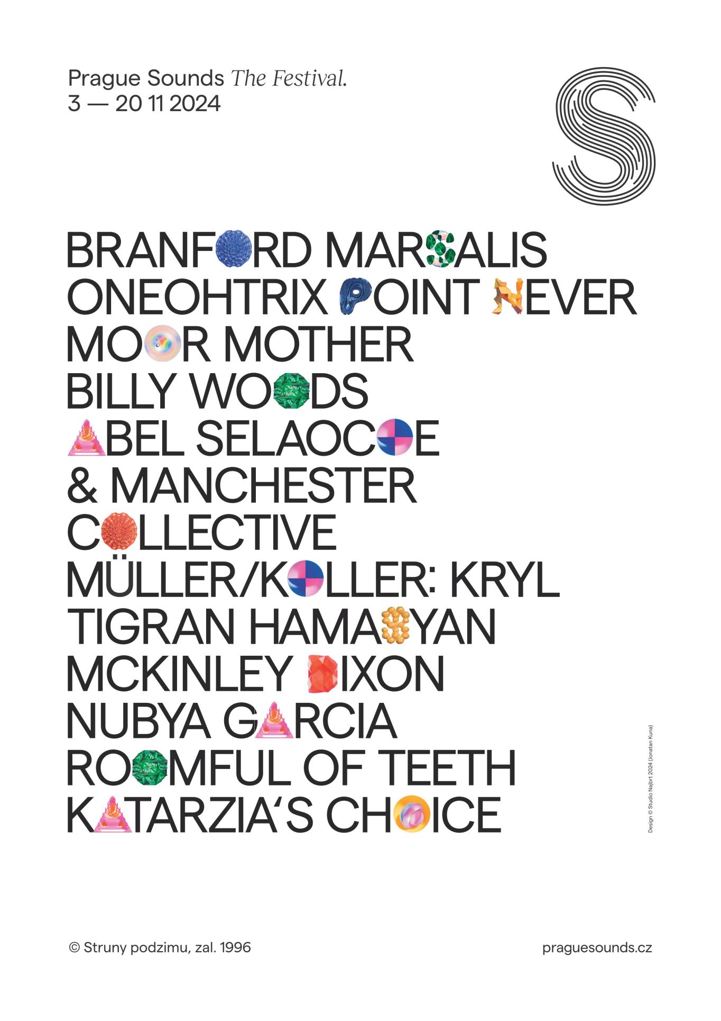

Hi-res fotografie: https://bit.ly/PragueSoundsPress
Kontakt pro press:
Jiří Sedlák, Prague Sounds
M: +420 604 868 914
E: sedlak@praguesounds.cz

